Native Americans and Tessellations
(Lesson 15)

Solution Key and Teacher’s Guide

ACTIVITY #1 – Which Polygons Tessellate?

1. Does a triangle tessellate? (Does 60 divide evenly into 360?)

SOLUTION: Yes, a triangle tessellates. To determine whether a regular polygon will tessellate, you must first find the measure of one interior angle. If that number divides evenly into 360, then the regular polygon will tessellate. (See the justification for the triangle below.)

2. Use the procedure above to find out which other regular polygons tessellate.

SOLUTION:

Measure of One Interior Angle Will the Regular Polygon Tessellate?
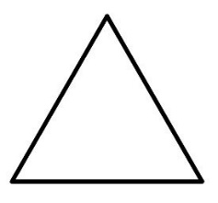
Divides evenly with no remainder
YES – a triangle tessellates
60

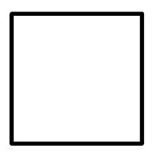
Divides evenly with no remainder
YES – a square tessellates
90

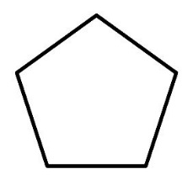
Does not divide evenly
NO – a pentagon does not tessellate
108

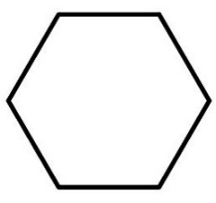
Divides evenly with no remainder
YES – a hexagon tessellates
120

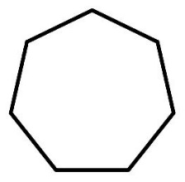
Does not divide evenly
NO – a heptagon does not tessellate

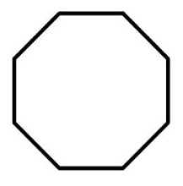
Does not divide evenly
NO – an octagon does not tessellate
135

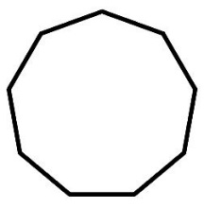
Does not divide evenly
NO – a nonagon does not tessellate
140

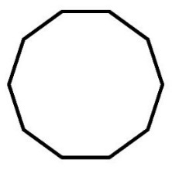
Does not divide evenly
NO – a decagon does not tessellate
144

Any other regular polygons?

NO, the above examples show a trend. As the number of sides of a regular polygon increases, the measure of each interior angle also increases. After the decagon, which has an interior angle measure of 144, the next number higher that divides evenly into 360 is 180. So the next regular polygon that could possibly tessellate would have to have an interior angle measure of 180. But it is impossible for a regular polygon to have each interior angle measure 180 because that would just result in a long line segment. After 180, 360 is the next, and last, factor of 360. It is also impossible for a regular polygon to have an interior angle measure of 360, because each segment would just double-back on itself resulting in a figure that is, once again, just a line segment.

ACTIVITY #2 – Construct a Square and an Equilateral Triangle

How to construct a 7 cm x 7 cm square.

1) On your paper draw a 7 cm segment.

7 cm

2) Place a protractor at one end of your segment and mark a point at a angle.
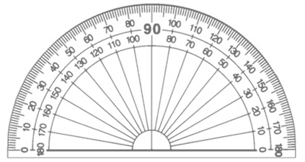

Use the straight edge of the protractor to line up your new point and endpoint of the
segment. Construct another 7 cm segment.

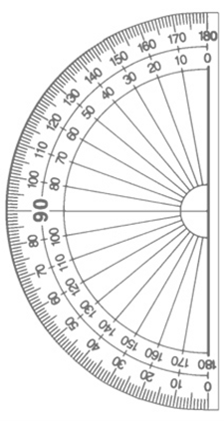

7 cm

3) Pick another open endpoint and repeat step 2.

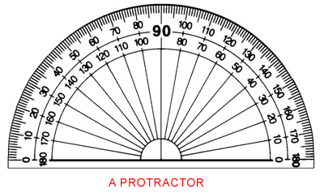
7 cm

4) Finally, connect the last two endpoints to complete your square.

How to construct a 7 cm equilateral triangle.

1) On your paper draw a 7 cm segment.

7 cm

2) On one end of your segment use a protractor and mark off a angle.

3) Use the straight edge of the protractor to line up your new point and endpoint.
Construct another 7 cm segment.

7 cm

4) Connect the other two endpoints to complete an equilateral triangle.

7 cm

5) Mark the midpoint of the base of the triangle.
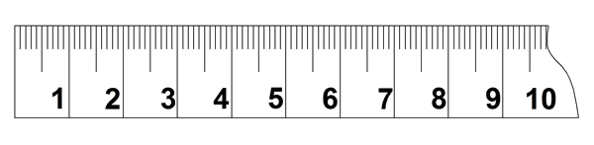
3.5 cm
3.5 cm

ACTIVITY #3 – Create a Tessellation Pattern Tile Using a Translation and Your
Square

* There are an infinite number of possible tiles that can be created. The following is just
one example.

- Using the left edge corners as starting and ending points, draw a random figure inside the square.

Starting Point
Ending Point
Random Figure

- Cut your random figure and translate (slide) straight across the square so the edges line up and carefully tape. Make sure the edges match exactly.

tape
Translate
tape

- Using the bottom edge corners as starting and ending points, draw a random figure inside the square.

Starting Point
Ending Point
Random Figure

- Cut your random figure and translate (slide) straight up to the top of the square so the edges line up and carefully tape. Make sure the edges match exactly.

Translate
tape
tape

- You have now created a pattern tile which will tessellate.

To make your pattern cover a surface:

Color your tessellation – have some fun with it!

ACTIVITY #4 – Create a Tessellation Pattern Tile Using a Rotation and Your
Equilateral Triangle

* There are an infinite number of possible tiles that can be created. The following is just
one example.

- Using the left edge corners as starting and ending points, draw a random figure inside the triangle.

Starting Point
Ending Point
Random Figure

- Cut out your random figure and rotate (using the top corner as point of rotation) so your random figure matches up with the right edge and carefully tape. Make sure the edges match exactly.

Point of Rotation
tape
tape
Rotate 60°

- Using the bottom left corner and the midpoint of the bottom edge as starting and ending points, draw a random figure inside the triangle.

Starting Point
Ending Point (Midpoint)
Random Figure

- Cut out your random figure and rotate (using the midpoint as point of rotation) so your random figure matches up with the bottom of the triangle and carefully tape. Make sure the edges match exactly.

Rotate 180°
tape

- You have now created a pattern tile which will tessellate.

To make your pattern cover a surface:

…Rotate your pattern in all directions so edges of the pattern fit together like a puzzle…

The pattern tile will fit together with itself if you rotate it 60° using, as the point of rotation, the original top of the triangle. Do this until you have six pattern tiles all touching at that point. Fit the pattern tile to the outside of this new figure, and repeat the process until you have completely filled the paper. (See next page.)

Color your tessellation – have some fun with it!

ACTIVITY #5 – Constructing a Classroom Quilt

Tape the classroom set of papers together whichever way they look best – portrait or landscape or both! Perhaps, allow the students to determine how they should be arranged.
QUESTIONS

- Why are an equilateral triangle, a square, and a hexagon the only regular polygons that will tessellate?

SOLUTION: In Activity #1 we discovered that a regular polygon will tessellate only if the measure of its interior angle is a factor of 360°. The interior angle measure of an equilateral triangle (60°), square (90°), and regular hexagon (120°) are all factors of 360°, and are the only regular polygons whose interior angle measures satisfy this criteria.

- Is it possible to construct a tessellation using a square with a rotation? Explain.

SOLUTION: YES.

Using the techniques of this lesson, if the random figure is cut from one side and rotated 90° to an adjacent side, using the included vertex as the point of rotation, you will create a pattern tile that will tessellate. The pattern tile will have to be rotated appropriately to make the pieces fit together. For example, using the square and the first random figure from Activity #3…

Random Figure
Included Vertex
Rotate 90°

The resulting pattern tile would look like the following figure.

And the tessellation would begin to look like this. (Size has been reduced to demonstrate the tessellation effect.) Because a new square has been formed, you may tessellate it in a variety of ways.

- Is it possible to construct a tessellation using an equilateral triangle with a translation? Explain.

SOLUTION: NO.

Using the techniques of this lesson, if you cut a random figure and slide (no rotation – only a slide) it across the triangle, it would need a side parallel to the original side in order for the starting and ending points to both rest upon. In this case, there would only be a point (the opposite vertex of the triangle).

If you cut a random figure and try to slide it across the midpoint of the same side, you will create an empty space from where you cut it, but it would simply be taped on top of the existing triangle on the other side of the midpoint. Because it wouldn’t protrude out from the triangle, this would not allow it to fill in the empty space when you attempt to tessellate the pattern tile.

- Which transformations (translation and rotation) are possible using a hexagon? Explain.

SOLUTION: BOTH.

All even number sided regular polygons (including the hexagon) can use the translation technique in this lesson, because the opposite side to the one that the random figure was drawn on is always parallel, and has the same length. This means if you cut the random figure and slide it across, it will match up exactly on the opposite side.

All regular polygons (including the hexagon) can use the rotation technique in this lesson. Simply cut and rotate the random figure, the same number of degrees as the measure of an interior angle, to an adjacent side using the included vertex as the point of rotation. The random figure will match up exactly to that side.

- Create a story explaining your tessellations.

SOLUTION: These stories are student generated and will all be different. Students should use the story of the excerpt taken from “The Morning Star, Star Quilt” as motivation for creating their story.

EXTENSIONS

Further interesting activities could include students making a tessellation page using a hexagon and trying both the translation and rotation methods. For an additional challenge, students could try the rotation method using both a vertex for the point of rotation and the midpoint of a side for a point of rotation (as was done with the equilateral triangle in Activity # 4).

